

**NATIONAL ALUMINIUM COMPANY LIMITED**

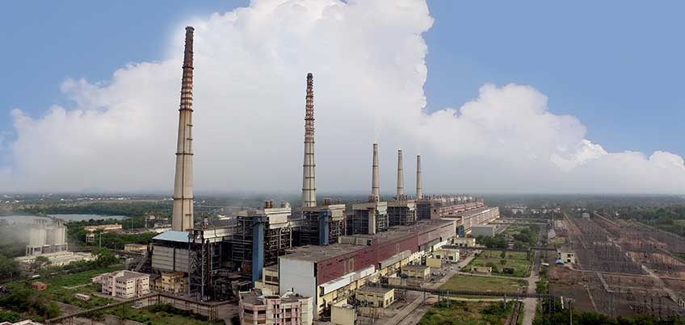

**REPORT ON VOCATIONAL TRAINING**

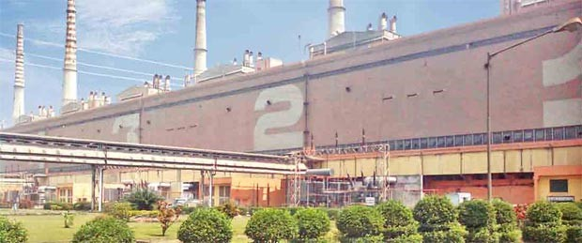

**IN THE GUIDANCE OF:**

MR. LATIFUR REHMAN

SENIOR MANAGER

SYSTEMS DEPARTMENT

**SUBMITTED BY:**

DEBASIS BADA

APP. NO. –CP2023CS0001

SEMESTER – 4TH

BRANCH – COMPUTER SCIENCE ENGINEERING

**ACKNOWLEDGEMENT**

Industrial training is an integral of engineering curriculum providing engineers which first hand and practical aspects of there studies. It gives them knowledge about the work and circumstances existing in the company the preparation of this report would not have possible without the valuable contribution of the **NALCO** family compromising of several experience engineers in their respective field of work. It gave me pleasure in completing my training at **Captive Power Plant (CPP)** of **NALCO** in Angul and submitting the training report of the same.

I am thankful to my guide **MR.LATIFUR REHMAN** who teaches me every minute details of plant and practical knowledge that is without your effort the present form of this report is not possible and guided us regarding **SYSTEM DEPARTMENT IN NALCO CPP PLANT**.

**DEBASIS BADA**

**ROLL NO – 407014**

**REGD. NO- 2101105158**

**IGIT, SARANG**

**CERTIFICATE**

This is to certify that the project report on **SYSTEM DEPARTMENT** is the bonafide work of **MR.DEBASIS BADA** under my supervision and guidance for practical fulfilment of the requirements of the award of summer internship during **2022-23**

**(LATIFUR REHMAN)**

**SENIOR MANAGER,**

**SYSTEM DEPARTMENT, CPP.**

**CONTENT**

1. COMPANY PROFILE
2. CAPTIVE POWER PLANT

* Schematic Diagram of CPP
* Generation Capacity of CPP
* Salient Features of CPP

1. SYSTEM DEPARTMENT IN CPP
2. PYTHON
3. STRUCTURED QUERY LANGUAGE(SQL)
4. SQL USING PYTHON
5. STUDENT DATABASE USING PYTHON AND SQL
6. CODE
7. OUTPUT

**COMPANY PROFILE**

National Aluminium Company Limited (NALCO) is a Schedule ‘A’ Navratna CPSE established on 7th January, 1981 having its registered office at Bhubaneswar.  It is one of the largest integrated Bauxite-Alumina-Aluminium- Power Complex in the Country. At present, Government of India holds 51.28% of paid up equity capital. The Company has been operating its captive Panchpatmali Bauxite Mines for the pit head Alumina refinery at Damanjodi, in the District of Koraput in Odisha and Aluminium Smelter & Captive Power Plant at Angul.  As a part of green initiative, NALCO has installed 198 MW Wind Power Plants at various locations in India and 800 kWp roof top Solar Power Plants at its premises to join hands for carbon neutrality. From the days of first commercial operation since 1987 the Company has continuously earned profits for last 36 years. NALCO is one of the leading foreign exchange earning CPSEs of the Country. The Company continues to retain its position of lowest cost producer in Bauxite and Alumina production in the World in 2022.

Capitalising the market opportunity the Company could achieve high sales realisation, positively impacting the top line and bottom line in FY 2021-22. Revenue achieved Rs. 14,181 crore and Highest ever PAT of Rs. 2,952 crore achieved in FY 2021-22.

Even with subdued pricing situation in FY 2022-23, with focus on domestic market the Company achieved highest ever revenue from operation of Rs.14,255 Crore. However, with increase in input cost, the PAT achieved was Rs. 1,544 crore in FY 2022-23. NALCO achieved Full capacity Aluminium production of 4.6 lakh tonne, with all 960 POTs in operation in its Aluminium Smelter for the 2nd consecutive year in FY 2022-23.

The Company has a 68.25 lakh TPA Bauxite Mine & 21.00 lakh TPA (normative capacity) Alumina Refinery located at Damanjodi in Koraput district of Odisha, and 4.60 lakh TPA Aluminium Smelter & 1200MW Captive Power Plant located at Angul, Odisha.

The Company has regional sales offices in Delhi, Kolkata, Mumbai, Chennai and 8 operating stockyards at various locations in the Country to facilitate domestic consumers. In addition, NALCO has its own bulk shipment facility for export of products.

With its consistent track record in capacity utilization, technology absorption, quality assurance, export performance and posting profits, NALCO is a bright example of India’s industrial capability.

NALCO is the first Public Sector Company in the country to venture into international market in a big way with London Metal Exchange (LME) registration since May, 1989. The Company is listed at Bombay Stock Exchange (BSE) since 1992 and National Stock Exchange (NSE) since 1999. Besides, ISO 9001, ISO 14001, ISO 45001, ISO 50001 & SA 8000 certifications, NALCO’s Data Centre at Corporate Office and Disaster Recovery Site at Alumina Refinery certified for Information Security Management System and awarded ISO 27001:2013 Certification and Accreditation from International Accreditation Services, USA.”

To face the challenges of ever-evolving market and position the Company in a sustainable growth path, a corporate plan has been developed with well-defined 3 year action plan, 7 year strategy & 15 years vision of being a Premier and Integrated Company in the Aluminium value chain with strategic presence in Mining both domestic & global, Metals and Energy sectors. The Corporate Plan has chalked out a roadmap for multifold growth in revenue and Profit by 2032.

While Company is sustaining its operational excellence driven by its corporate plan, the Company is also having well carved plans for expansion programs. Presently, the Company is working in major projects like:

* 5th stream Alumina Refinery, which will enhance the Refinery capacity from 2.1 million tonne to 3.1 million tonne.
* To support the Alumina Refinery and raw material security, the Company is developing Pottangi bauxite Mines. Obtaining all clearances under process.
* Utkal D & E Coal Mines: Mining activities already started. It will add to the bottom line by reduction in coal procurement cost. For Utkal-E, all clearances are in advance stage.

As part of backward integration, the Company has established a caustic soda plant in JV with Gujarat Alkalies & Chemicals Limited (GACL) in Gujarat. Production started in May’2022 and Despatch of caustic soda to NALCO started in Aug’2022.

NALCO is a leading name in the industrial map of Eastern India. True to the spirit, the Company is taking the lead to bring in a significant change in the Industrial map of Odisha. The Company has formed JV Company named ‘Angul Aluminium Park Private Ltd’ (AAPPL) with Odisha Industrial Infrastructure Development Corporation (IDCO) to give a boost to ancillary, upstream & downstream products related to aluminium industry.

To acquire strategic mineral assets in overseas location and making supply in India, NALCO has formed a JV Company named Khanij Bidesh India Limited (KABIL) with HCL and MECL.

The Company, while climbing the ladder of success has strived hard to play a significant role in the socio-economic development in its operational areas through empathetic CSR activities. Rehabilitation of displaced families, employment, income generation, health care and sanitation of local people, education & skill development, providing safe drinking water, development of infrastructure, pollution control, environmental measures, rural development, promotion of arts, crafts & culture and various humanitarian good will missions have earned NALCO a place of pride in the corporate world.

With encompassing initiatives to provide a better living to the periphery areas and contribute to nation building the Company has taken many ambitious projects. Its notable efforts include Indradhanush scheme, where the Company has already sponsored more than one thousand tribal children of Maoist infested Damanjodi sector and provided education to them in 3 reputed residential schools. Meritorious girl students of BPL families at Angul and Damanjodi sector have been adopted with financial support by the Company under ‘Nalco ki Ladli’ scheme in line with Govt’s ‘Beti Bachao, Beti Padhao’ Mission. Recognizing the healthcare needs as one of the critical need, NALCO is operating 8 MHUs (Mobile Health Units) and one OPD in peripheral villages of its plants by which more than lakh patients treated every year.

Responding to the call of Govt of India, NALCO actively participated in Swachh Bharat Abhiyan by constructing toilets in various districts of its operating areas and has also completed 11 periphery villages Open Defecation Free (ODF) in Damanjodi and Angul sector.

NALCO has taken the responsibility of Shri Jagannath Temple, Puri & its surrounding under PM’s Iconic Shrine Development Programme to upgrade the infrastructure & maintain cleanliness.

The Company has given special emphasis on Renovation and beautification of Gandhi Park as a tourist spot, temple illumination, beautification of Puri town with thematic painting based on Jagannatha culture, operation of Battery-Operated Vehicle from Jagannath Ballav Math to Shree Jagannath Temple and Railway Station for differently-abled passengers, senior citizens and sick people, RO based water posts at different locations in side Puri Town.

The company since inception has marched ahead with sustainable growth, perpetual profits while exhibiting deep empathetic concern for the society. Etched in the hearts of millions of people of Odisha as modern industrial “Konark”, the company has been able to create a special place for itself for the people it works with. Enhancing the stakeholders’ wealth has remained the prime mover to steam Company’s growth but nonetheless the driving spirit remains to bring smiles in the face of multitude of its stakeholders.

**MISSIONS OF NALCO:**

1. To achieve sustainable growth in business through diversification, innovation and global competitive edge.
2. To satisfy the customers and shareholders, employees and all other stake holders.
3. To continuously develop human resources, create safe working conditions, improve productivity and quality and reduce cost and waste.
4. To be a good corporate citizen, protecting and enhancing the environment as well an discharging social responsibility in order to ensure sustainable growth.
5. To intensify R&D for technology development.

**CAPTIVE POWER PLANT**

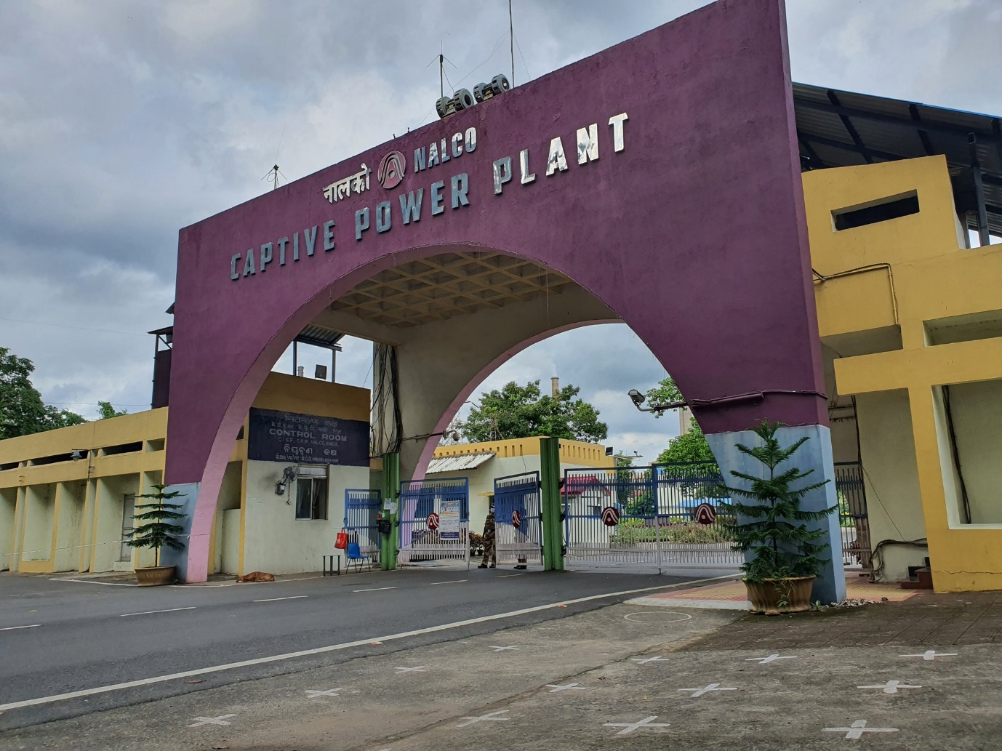

Presently the Captive Thermal Power Plant has a generation capacity of 1200 MW (10X120MW). While the captive thermal power plant provides entire electric power requirement of aluminium smelter, it also feeds for approximately 35 MW of the power requirement to the alumina refinery through the State Grid.

The location of captive thermal power plant at Angul is also strategic to the availability and supply of coal from nearby Talcher Coalfields. The 18.5 KM captive railway system links the captive thermal power plant to the Talcher coalfields, enabling transport of the critical and bulk requirement of coal.

**The Salient Features**

* Micro-processor based burner management system for optimum thermal efficiency.
* Computer controlled data acquisition system for on-line monitoring.
* Automatic turbine run-up system.
* Specially designed barrel type high pressure turbine.
* Advanced electrostatic precipitator (99.9% efficiency) to control pollution.
* Wet disposal of ash.
* Zero discharge of effluents.
* High Concentrate Slurry Disposal (HCSD) System for ash disposal.
* High plant load factor.

The water for the Plant is drawn from River Brahmani through a 7 KM long triple circuit pipeline. The coal demand is met from a mine of 3.5 Million TPA capacity opened up for Nalco, initially at Bharatpur in Talcher by Mahanadi Coalfields Limited. The Power Plant is inter-connected with the State Grid.

**SYSTEM DEPARTMENT**

A server room is an important area for many companies that is set up to computer servers and other equipment. These rooms may have been originally designed specifically for this purpose, or they may have been created as the need for one came up. Either way, a good server room will provide an environment where computer equipment can safely operate in one location so that networking and other activities are made easier and more effective. Understanding the proper setup and configuration of a server room will help with creating and maintaining it effectively.

Many companies will boost their productivity and become more efficient by using a server. Same goes with **CPP**. In system department it is used for managing all types of data.

Servers store, manage, and deliver data to the workstations on a network. Typically, they are more powerful than an average workstation, providing enhanced security and easy integration with backup/recovery tools. Several [Dell PowerEdge servers](https://www.dell.com/en-us/work/shop/dell-poweredge-servers/sc/servers), starting with the T140, are suited for companies migrating from peer-to-peer networks.

**PYTHON**



Python is an interpreted, object-oriented, high-level programming language with dynamic semantics developed by Guido van Rossum. It was originally released in 1991. Designed to be easy as well as fun, the name "Python" is a nod to the British comedy group Monty Python. Python has a reputation as a beginner-friendly language, replacing Java as the most widely used introductory language because it handles much of the complexity for the user, allowing beginners to focus on fully grasping programming concepts rather than minute details.

**Python Use Cases**

* Creating web applications on a server
* Building workflows that can be used in conjunction with software
* Connecting to database systems
* Reading and modifying files
* Performing complex mathematics
* Processing [big data](https://www.teradata.com/Solutions/Big-Data)
* Fast prototyping
* Developing production-ready software

Professionally, Python is great for backend web development, data analysis, [artificial intelligence](https://www.teradata.com/Solutions/Artificial-Intelligence), and scientific computing. Developers also use Python to build productivity tools, games, and desktop apps.

**Features and Benefits of Python**

* Compatible with a variety of platforms including Windows, Mac, Linux, Raspberry Pi, and others
* Uses a simple syntax comparable to the English language that lets developers use fewer lines than other programming languages
* Operates on an interpreter system that allows code to be executed immediately, fast-tracking prototyping
* Can be handled in a procedural, object-orientated, or functional way

**STRUCTURED QUERY LANGUAGE (SQL)**

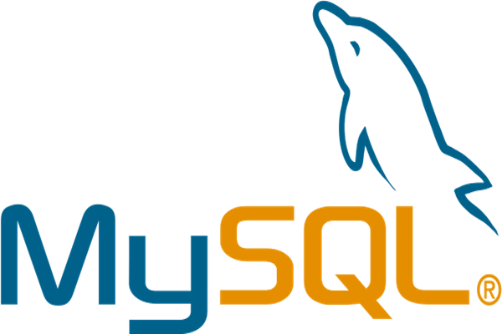

Structured Query Language (SQL) is a standardized programming language that is used to manage [relational databases](https://www.techtarget.com/searchdatamanagement/definition/relational-database) and perform various operations on the data in them. Initially created in the 1970s, SQL is regularly used not only by database administrators, but also by developers writing data integration scripts and data analysts looking to set up and run analytical queries.

The term SQL is pronounced ess-kew-ell or sequel.

SQL is used for the following:

* modifying database table and index structures;
* adding, updating and deleting rows of data; and
* retrieving subsets of information from within relational database management systems ([RDBMSes](https://www.techtarget.com/searchdatamanagement/definition/RDBMS-relational-database-management-system)) -- this information can be used for transaction processing, analytics applications and other applications that require communicating with a relational database.

SQL queries and other operations take the form of commands written as statements and are aggregated into programs that enable users to add, modify or retrieve data from database tables.

A table is the most basic unit of a database and consists of rows and columns of data. A single table holds records, and each record is stored in a row of the table. Tables are the most used type of database objects, or structures that hold or reference data in a relational database. Other types of database objects include the following:

* **Views** are logical representations of data assembled from one or more database tables.
* **Indexes** are lookup tables that help speed up database lookup functions.
* **Reports** consist of data retrieved from one or more tables, usually a subset of that data that is selected based on search criteria.

Each column in a table corresponds to a category of data -- for example, customer name or address -- while each row contains a data value for the intersecting column.

Relational databases are relational because they are composed of tables that relate to each other. For example, a SQL database used for customer service can have one table for customer names and addresses and other tables that hold information about specific purchases, product codes and customer contacts. A table used to track customer contacts usually uses a unique customer identifier called a key or [*primary key*](https://searchsqlserver.techtarget.com/definition/primary-key) to reference the customer's record in a separate table used to store customer data, such as name and contact information.

**SQL USING PYTHON**

SQL, which stands for structured query language, is a programming language in which the user queries relational databases. Data scientists use SQL in Python in a variety of instances, dictated by the use case at hand or by personal preference. SQL is primarily used for organizing data, especially in training queries, as well as for ad-hoc analysis of model results. Several other positions can also reap the benefits of SQL, including software engineers, data and business analysts and data engineers.

* import Python library
* connect to database
* create a cursor object so you can use SQL commands

**STUDENT DATABASE USING PYTHON AND SQL**

CODE:

import sqlite3  
  
# Create a connection to the database  
conn = sqlite3.connect('student.db')  
cursor = conn.cursor()  
  
# Create the student table if it doesn't exist  
cursor.execute('''  
 CREATE TABLE IF NOT EXISTS students (  
 roll_no INTEGER PRIMARY KEY,  
 name TEXT,  
 age INTEGER,  
 branch TEXT,  
 cgpa FLOAT  
 )  
''')  
  
  
# Function to add a new student to the database  
def add_student(roll_no, name, age, branch, cgpa):  
 cursor.execute('INSERT INTO students (roll_no, name, age, branch, cgpa) VALUES (?, ?, ?, ?, ?)',  
 (roll_no, name, age, branch, cgpa))  
 conn.commit()  
 print("Student added successfully.")  
  
  
# Function to retrieve all student data from the database  
def get_students():  
 cursor.execute('SELECT * FROM students')  
 rows = cursor.fetchall()  
 if len(rows) == 0:  
 print("No students found.")  
 else:  
 for row in rows:  
 print(f"Roll No: {row[0]}, Name: {row[1]}, Age: {row[2]}, Branch: {row[3]}, CGPA: {row[4]}")  
  
  
# Function to search for a student by roll number  
def search_student(roll_no):  
 cursor.execute('SELECT * FROM students WHERE roll_no = ?', (roll_no,))  
 row = cursor.fetchone()  
 if row is None:  
 print("Student Not Found.")  
 else:  
 print(f"Roll No: {row[0]}, Name: {row[1]}, Age: {row[2]}, Branch: {row[3]}, CGPA: {row[4]}")  
  
  
# Main program  
while True:  
 print("\n1. Add a Student")  
 print("2. Get All Students")  
 print("3. Search For a Student By Roll Number")  
 print("4. Quit")  
 choice = input("Enter Your Choice (1-4): ")  
  
 if choice == '1':  
 roll_no = int(input("Enter Student Roll Number: "))  
 name = input("Enter Student Name: ")  
 age = int(input("Enter Student Age: "))  
 branch = input("Enter Student Branch: ")  
 cgpa = float(input("Enter Student CGPA: "))  
 add_student(roll_no, name, age, branch, cgpa)  
 elif choice == '2':  
 get_students()  
 elif choice == '3':  
 roll_no = int(input("Enter Student Roll Number: "))  
 search_student(roll_no)  
 elif choice == '4':  
 break  
 else:  
 print("Invalid choice. Please try again.")  
  
# Close the database connection  
conn.close()

OUTPUT:

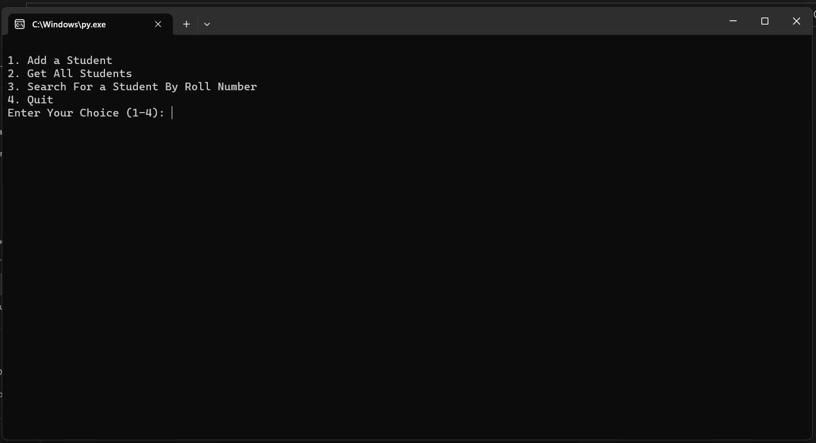

TO ADD STUDENT DATA:

PRESS 1 AND ENTER, THEN ADD STUDENT DATA

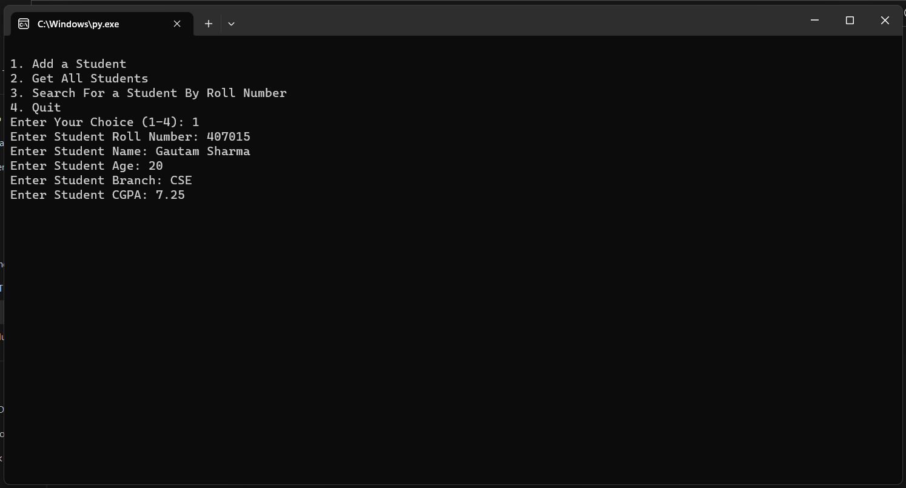

STUDENT ADDED SUCCESSFULLY: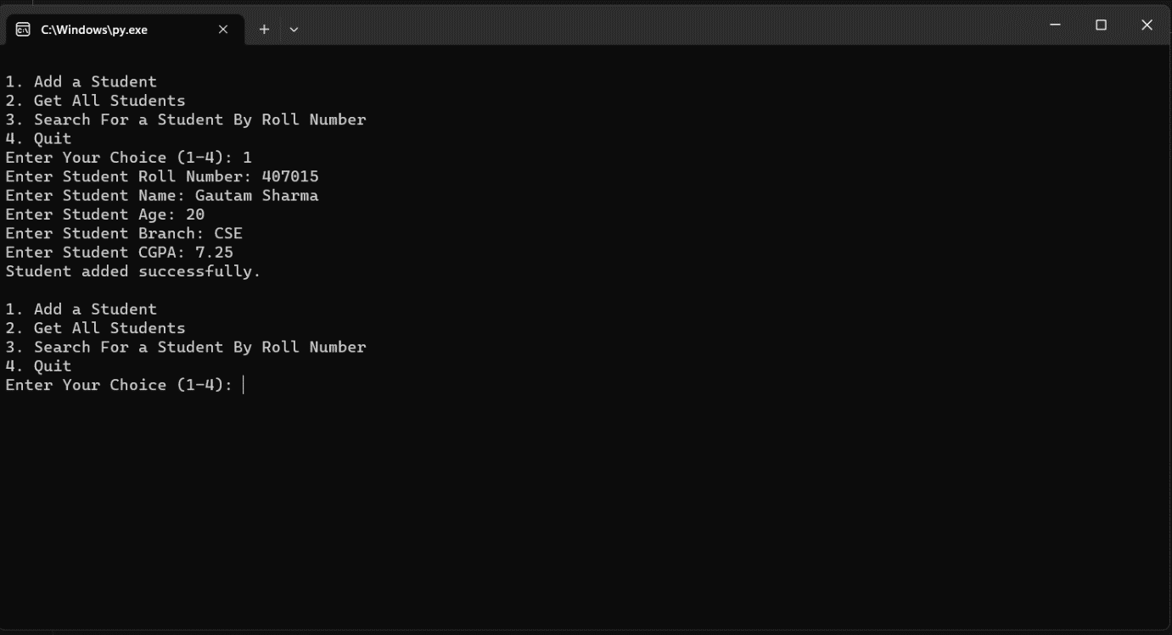

GET ALL STUDENT DATA:

TYPE 2 AND PRESS ENTER TO GET ALL STUDENT DATA.

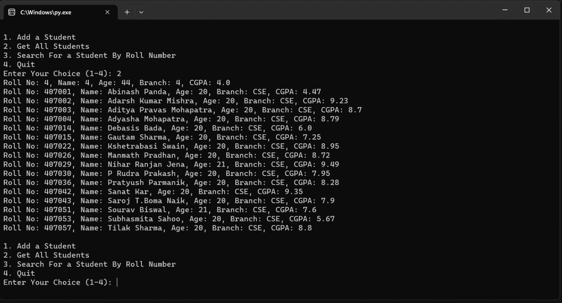

TO SEARCH FOR A STUDENT BY ROLL NUMBER:

AFTER TYPING 3, YOU CAN SEARCH STUDENT BY ENTERING RESPECTIVE ROLL NO.

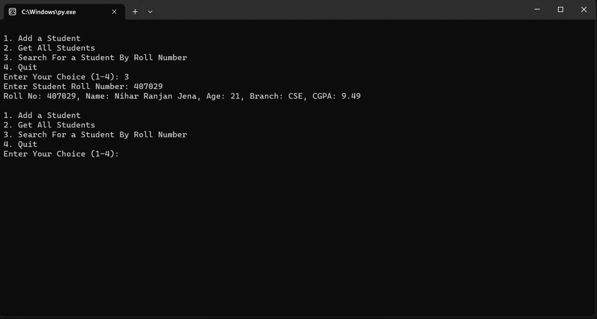

IF YOU ENTER WRONG ROLL NO.:

YOU WILL GET “No Student Found”

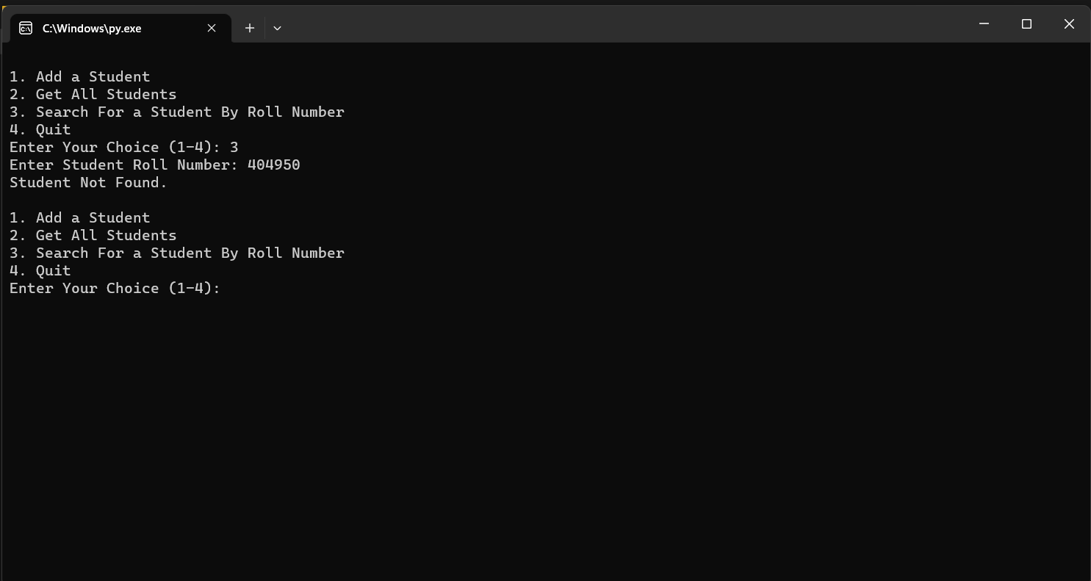

TO QUIT THE PROGRAM:

TYPE 4

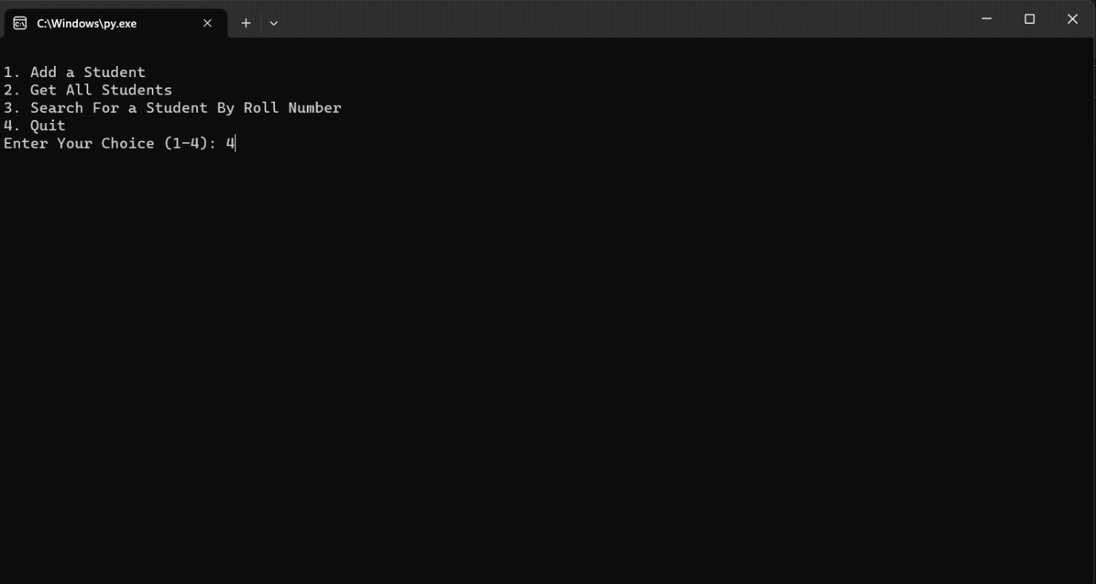

THEN IT WILL BE CLOSED.

**CONCLUSION**

Captive Power Plants play a significant role in meeting the energy needs industries and businesses. They offer several advantages, including reliable and uninterrupted power supply, cost savings and reduced dependence on the grid.

Captive Power Plant provide a reliable source of electricity, ensuring uninterrupted operations for industries. This is particularly crucial for sectors such as manufacturing, where any disruption in power supply can result in substantial losses. By generating their own power, businesses can maintain productivity and avoid downtime caused by grid and failures or load shedding.

However, it’s important to consider certain challenges associated with Captive Power Plants. Establishing and maintaining a Captive Power Plant requires substantial upfront investment, including infrastructure, equipment, and skilled personnel. Additionally, businesses need to comply with relevant regulations and ensure proper maintenance and operation of the power plant.

Maintenance activities for Captive Power Plants involve various aspects including routine inspections, preventive maintenance, repairs, and equipment upgrades. By conducting routine inspections, businesses can identify and address potential issues before they escalate into major problems. This includes checking and servicing the power generations equipment, monitoring fuel quality, and assessing the condition of auxiliary systems.

**THANK**

**YOU**